
Attack & Mitigation Documentation
Ian Kwan – CCNA

Purpose

The purpose of this lab is as follows: to document multiple layer two attacks on networking devices, to show the extent and effect of each attack, and to show the process of mitigating each attack to prevent further damage.

Background

In our modern world, new technological and virtual advancements are being made at a rapid pace. These developments push the boundaries of our ability to manipulate and use computing power to perform services and generate solutions, increasing society’s efficiency. But with these developments came an expected warning. Due to the novelty of these new technologies, current research about possible holes in security of data and privacy as well as control over technology only represents a small fraction of the possible security issues we may discover in the future.
Cybersecurity represents the future of data and privacy protection in the virtual world. Companies like Palo Alto, CrowdStrike, and Cisco are leaders of this industry, discovering possible breaches in security and developing strategies to patch those vulnerabilities. In the cybersecurity world, it is a constant battle for companies to keep up with the development of technology to ensure the protection of the public from possible attacks. In this lab we will focus on layer 2 attacks on network devices. First, we will discuss the materials and systems we will need to set up the experiment.
Operating systems manage communication between software and hardware. Without an operating system, our modern technology, built on software, would not function. Before Linux, the computing world was dominated by a commercialized system called Unix. This company privatized and monetized their operating system. In the computing world, privatization of different systems to generate profit was a common practice companies began to adopt. For the common public, this meant only a small fee for services and applications that they were willing to pay and expected to receive. But this system of privatization also came with a major issue.
Privatization led to the adoption of NDAs (non-disclosure agreements) which companies forced employees to sign to protect the secrets of their company and specifically the code they used for their systems. This inability to share source code for systems stemmed from the ability to duplicate a company’s systems if the code was leaked, putting the company out of business.
For the average person, this was not a problem because there was no value in knowing the code. But for developers and computer engineers of the time, not having access to the Unix code meant inability to make their own modifications for issues that they saw and knew how to improve. During this time Linus Torvalds and many others began to work on creating their own open-source operating system that would be free for the public to modify and use. The Linux Kernel, which Linus Torvalds created was named after him, by combining his first name Linus and Unix.
Linux is a type of operating system that is used for multiple purposes and comes with several benefits. It can be thought of as a system with seven key components: The bootloader, the kernel, the init system, the daemons, the graphical server, the desktop environment, and the applications.
The bootloader manages the booting process. On the user’s viewing interface, the bootloader is visible as the loading screen seen as the operating system boots up. The kernel is the core of the Linux system that manages the CPU (computing power unit), memory, and other core functions. The kernel is basically the foundation of the operating system and likewise it is the lowest level of the OS. The job of the Init system is to conduct and organize the software services. In basic terms, the Init system is in control of turning services on and off. A few examples include booting up the daemons and opening the user login screen. Daemons are in control of background processes that run without user interaction or intervention. They are started by the Init system and stay idle until specific events occur. The graphical server manages the graphics that users see on the screen. It’s often called the X server. The desktop environment oversees the interaction between the user and the screen, making sure commands like typing a command or selecting an icon go through to the system. And finally, applications are apps or software utilities that are compatible with the Linux system. Some applications are only compatible with other operating systems like Windows and macOS, but many are only available on Linux.
The reason why Linux is included in this background is because the Ettercap application, which is only fully supported on Linux systems, will be used for attacks in this lab. Ettercap is an open-source tool that developers use to test the security of their systems. It can perform multiple layer 2 attacks, which we will focus on in this lab.
Ettercap is most compatible with Linux OS. It was originally built for systems like Unix. The Ettercap program is used to directly plug into the OS libraries to perform function, but Windows uses a middleman system and has rigid malicious activity detection which prohibits many Ettercap functions. Thus, Ettercap works best on Linux as it can bypass other OS modifications that might affect the performance of its functions, like sniffing. Ettercap serves as a program that allows users to perform different types of attacks including ARP poisoning, man-in-the-middle (MITM) attacks, and abilities to target specific devices through interfaces. Ettercap can also sniff packets from devices once it floods or poisons a device and intercepts direct or broadcasted packet. Thus, Ettercap is a useful tool that we can use to demonstrate and conduct layer 2 attacks.
In this lab we will focus on two main layer 2 attacks: Mac Flooding and ARP poisoning attacks. The first attack that we will focus on is Mac Flooding. Mac flooding attacks primarily involve attacking a network device called a switch. Switches use a Content Addressable Memory (CAM) table to map the attached network and send packets towards the destination. In a Mac flooding attack, a user floods the CAM table of the switch, making the switch unable to add another entry for new ports. This forces the switch into a backup mode where if the switch doesn’t know the port to send a packet through, it broadcasts the packet through all ports. This allows a user connected to a different port to receive information dedicated to a different destination.
The second attack in this lab is ARP poisoning. ARP poisoning involves sending malicious ARP packets to corrupt the CAM tables of switches. This poisoning links a malicious MAC address to an actual host’s IP address. A switch forwards packets based on the learned MAC address in the CAM table. A corrupt CAM table causes a switch to forward traffic to the net hop with the learned malicious MAC address rather than towards the designated host. Using this concept, hackers can steal packets designated to another host. Hackers use ARP poisoning to act as an actual host on the network, stealing their packets and potentially sensitive and important information. This powerful attack causes a breach in both the network and the victim host’s privacy.

Configuration

Network Materials
In this lab we will need the following devices: 2 PC hosts, 1 switch, 1 router. We will start off with host configurations for the simulation network.

Host configurations

Turn off Window’s Defender Firewall
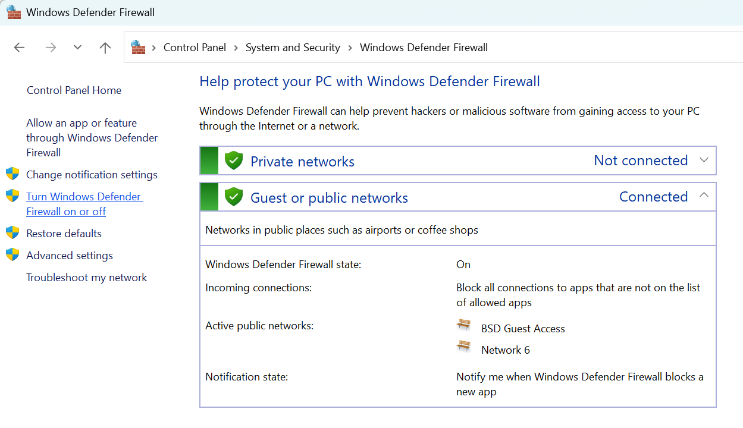
Turn off Windows Defender Firewall by matching these configurations then press “OK”. 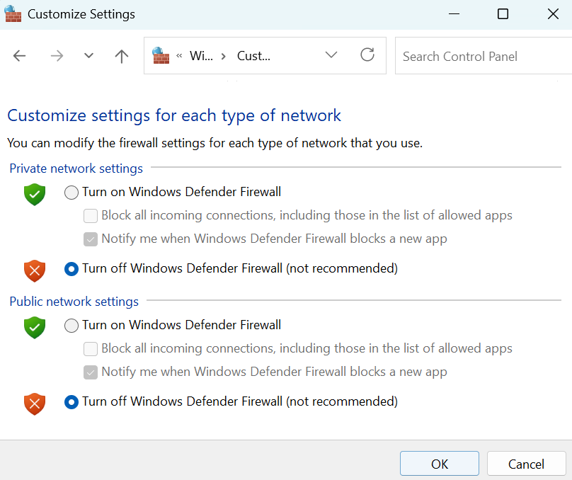
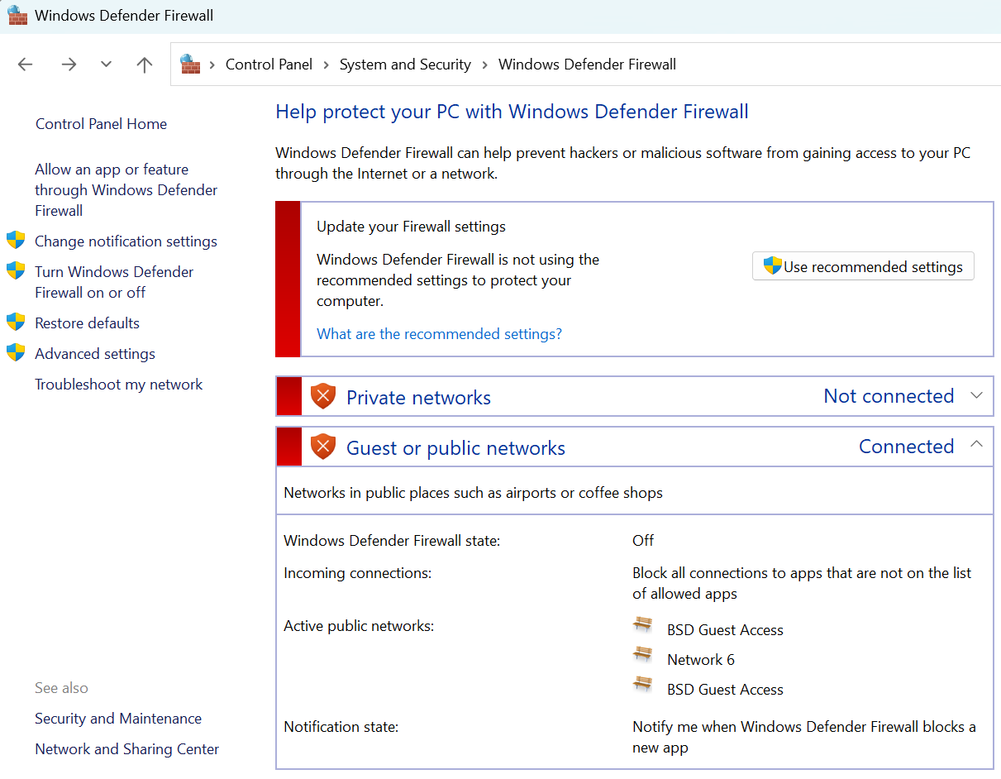
You have now successfully turned off Windows Defender Firewall!

Kali Linux Download

Materials Needed
- USB stick (min 8 GB, 16-32 recommended for OS + utilities)

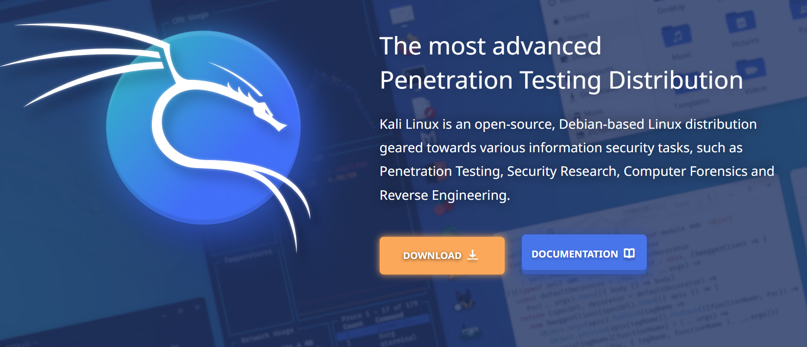
Head over to the Kali Linux website to download the installer. Kali Installer: https://www.kali.org/

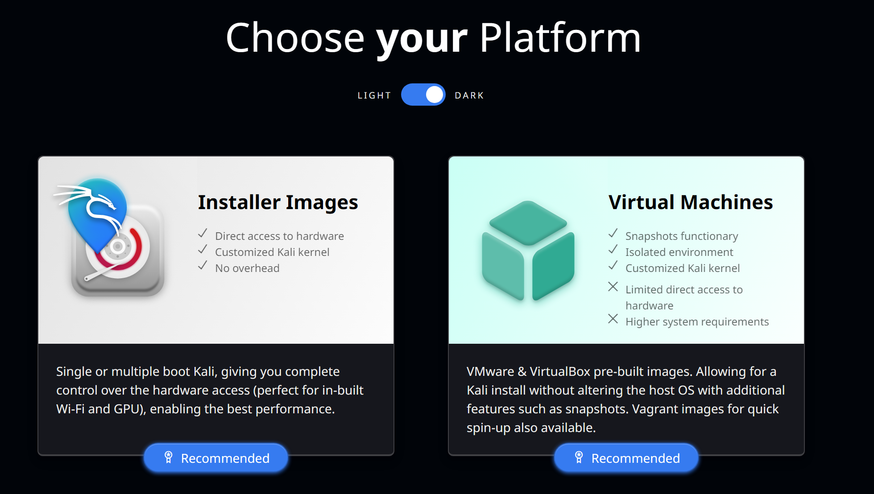Select the Installer images.
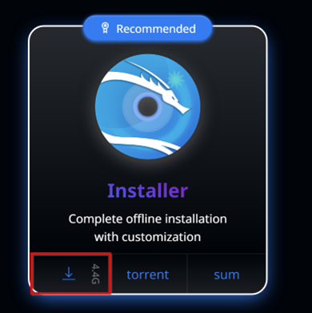
Then click the install icon for the Kali Linux Installer.

Rufus Download
Rufus: https://rufus.ie/
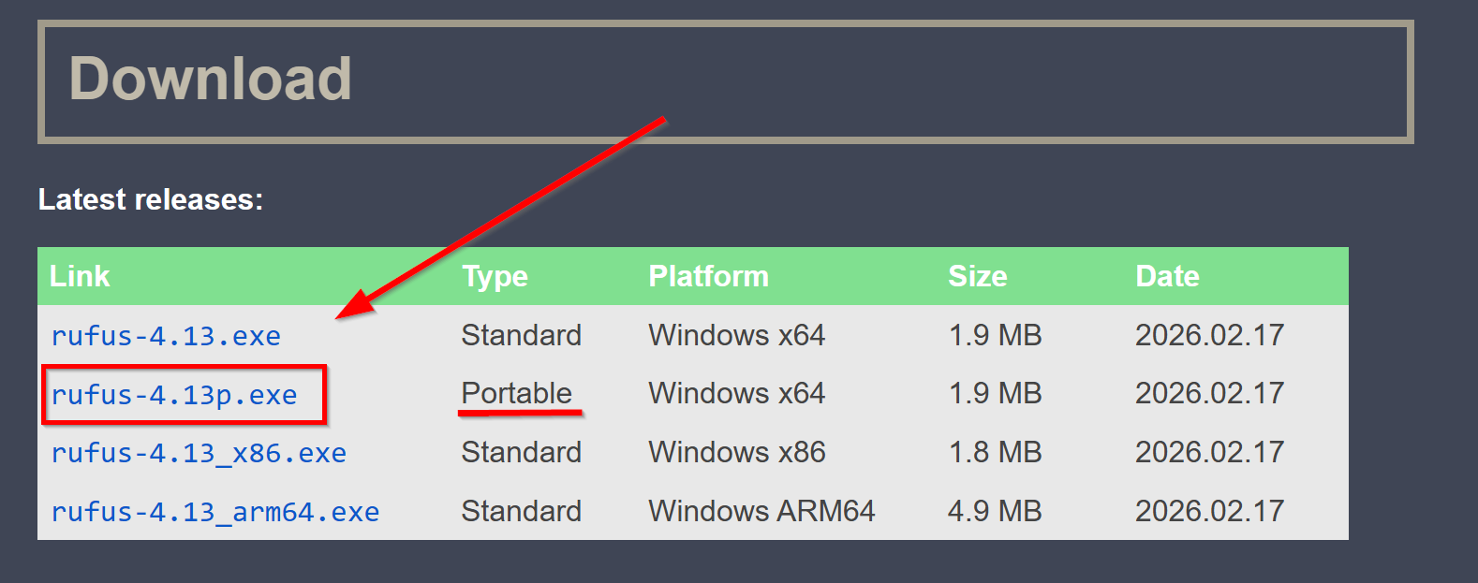
We will use rufus to help support the Kali Linux imaging process.

Then open the rufus-4.13p.exe file in the downloads folder of File explorer.

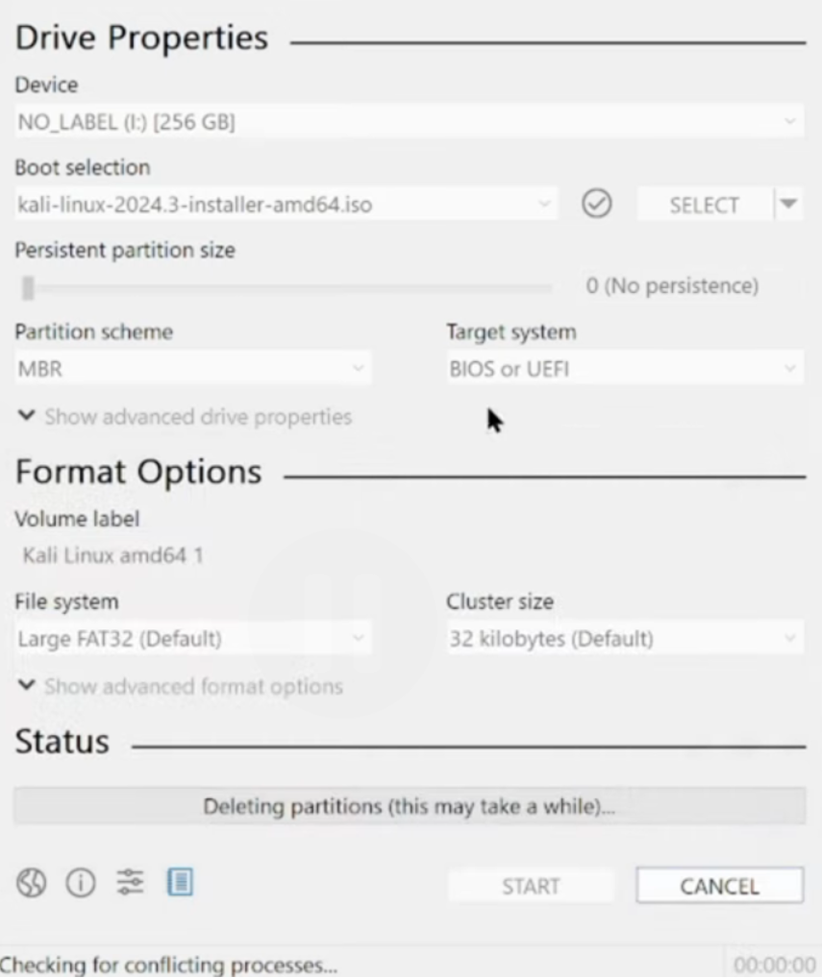
Copy these configurations and start rufus. This will delete all data on the USB stick that is being used for the imaging process. So, make sure to backup important data.

After you apply these configurations, restart your PC with the USB drive plugged in. Then as the machine boots, open the boot menu. On different system the button is different. But common buttons used to open into the boot menu include F8, F9, F12, or ESC.
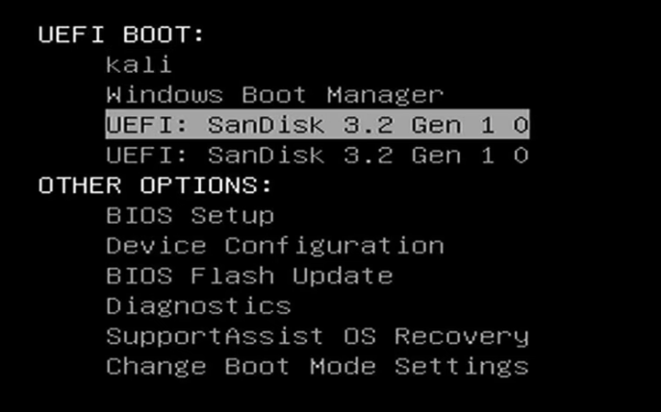Select USB file that you have created to boot from that file.
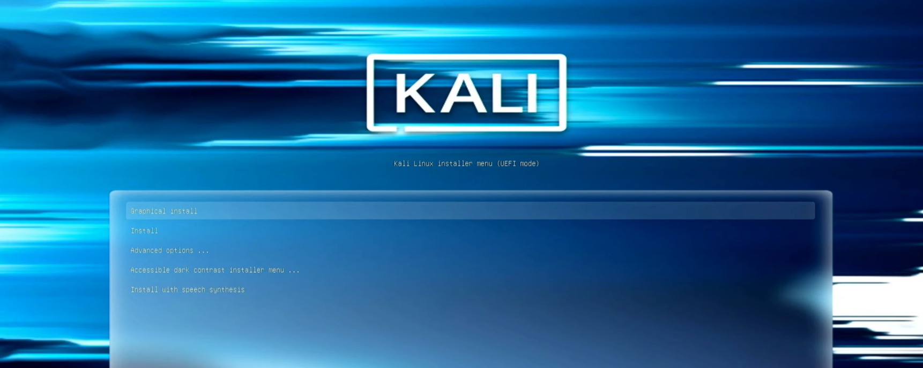During the imaging process, your PC should open to this screen.

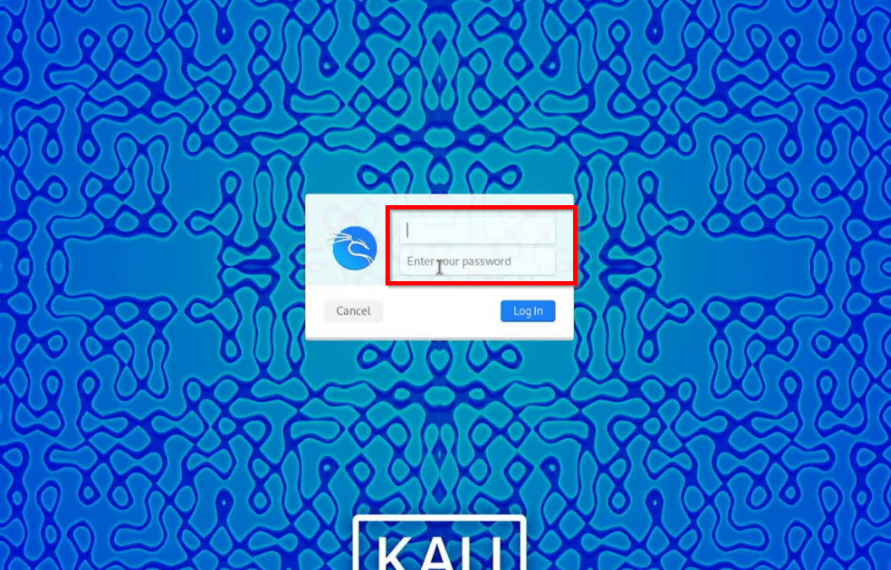
Specify the configurations that you would like as you finish the imaging process. The most important thing is that you configure your username and password to log into the system. After you have completed these configurations, Kali Linux is set up!

Ettercap Setup

Downloading and Opening Ettercap
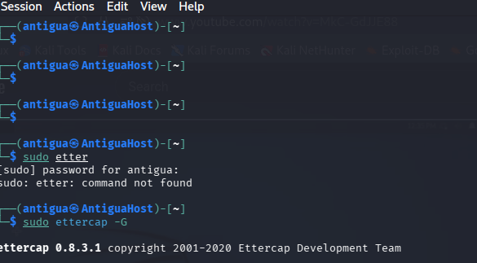
You can download Ettercap using the command sudo Ettercap -G in command prompt or open the preinstalled Ettercap-pkexec on Kali Linux.
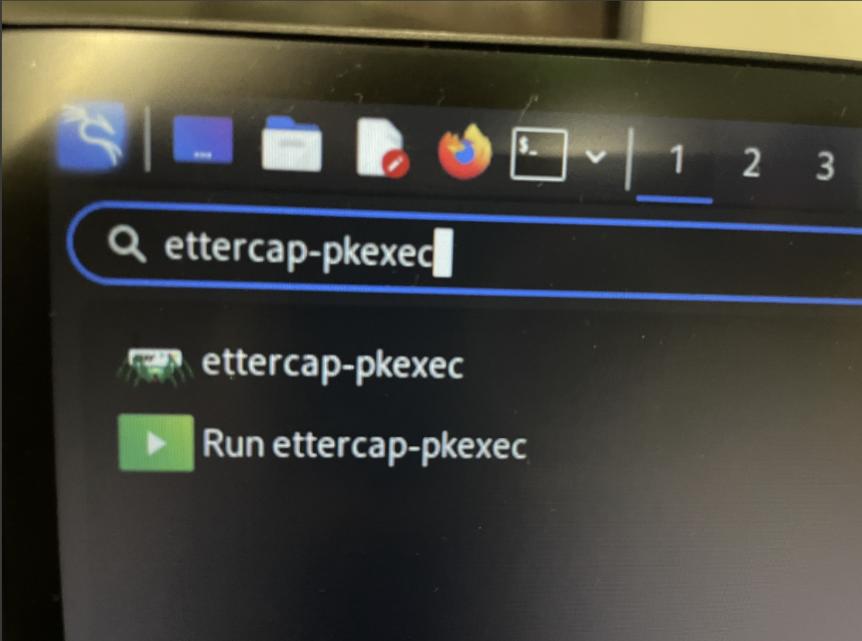
Type “ettercap-pkexec” into the search menu and click the application. Now you can start attacks with Ettercap.

Mac Flooding

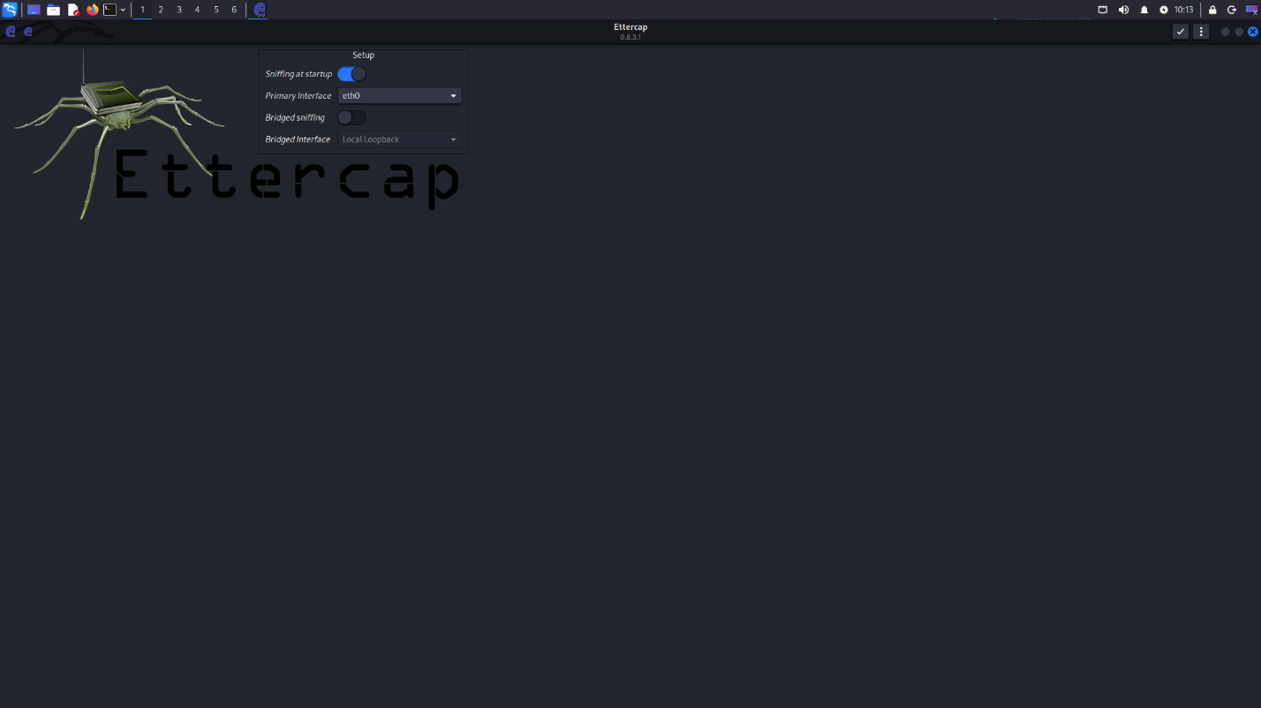
First select the interface you want to flooding from, then click the check mark button to begin the attack.

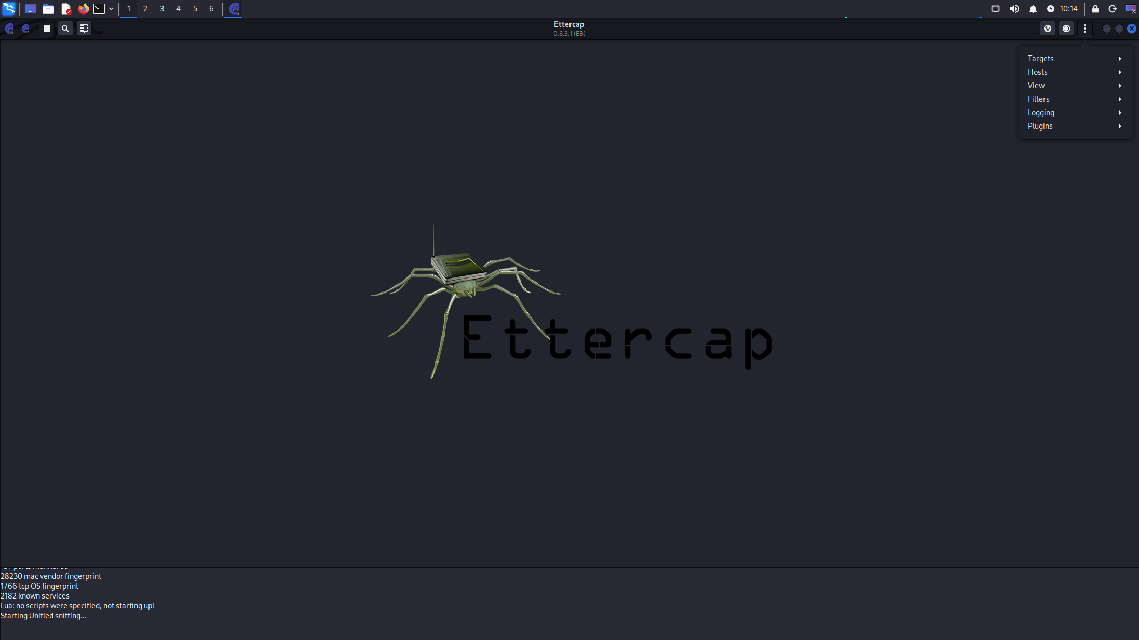
In the Ettercap main menu select the recording button to open the drop-down menu. Then select the plugins option. This should open your window up into the plugin menu.

Then select Manage plugins. This opens up a menu of multiple different attacks.

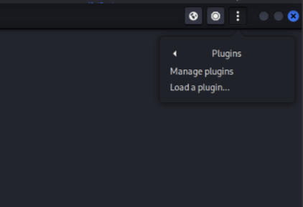
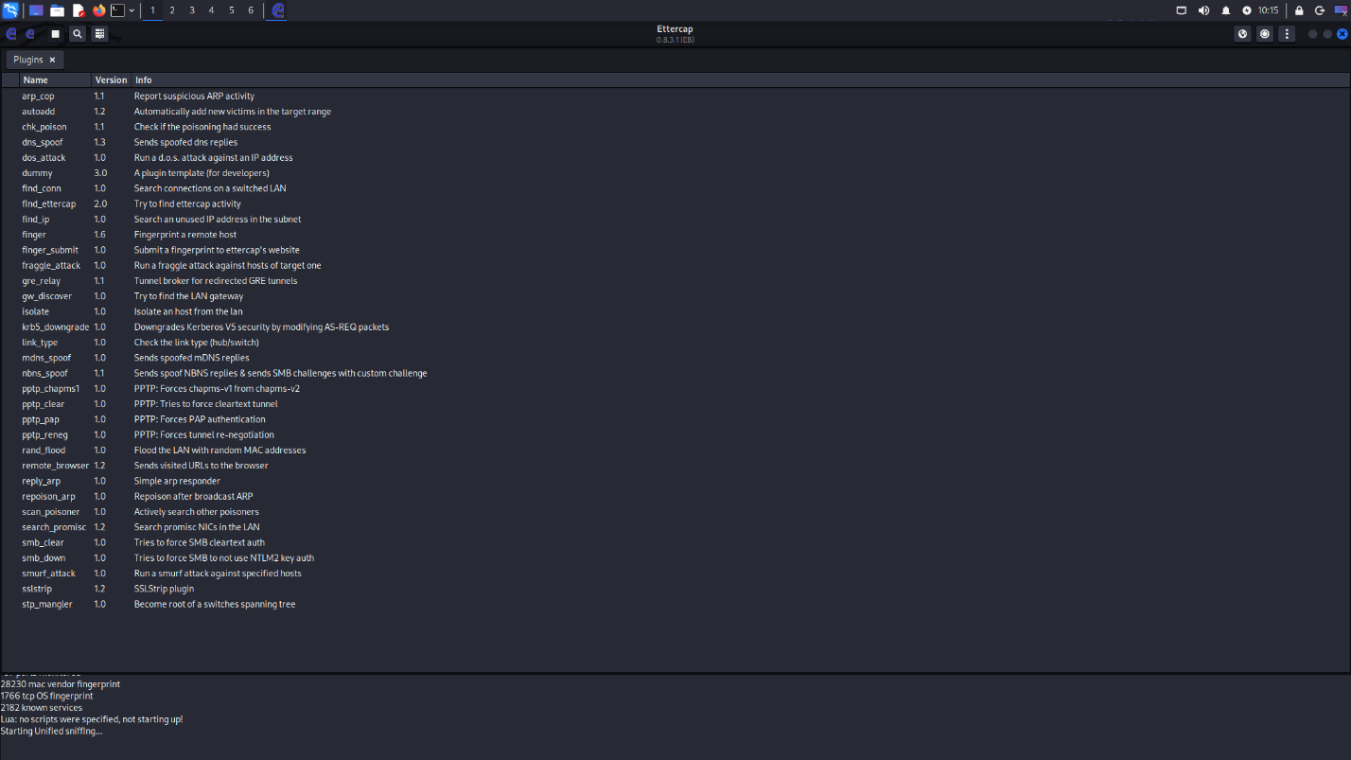
The plugin menu should open up into this menu. This will include multiple attacks that you can test and experiment with.

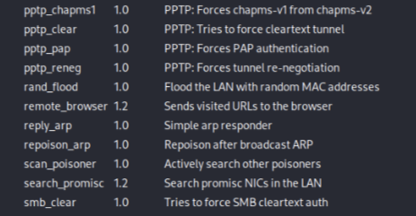
To perform a MAC flooding attack, we will use the rand_flood function. Click the option. This should open your window up to select the interface you would like to perform the attack through.

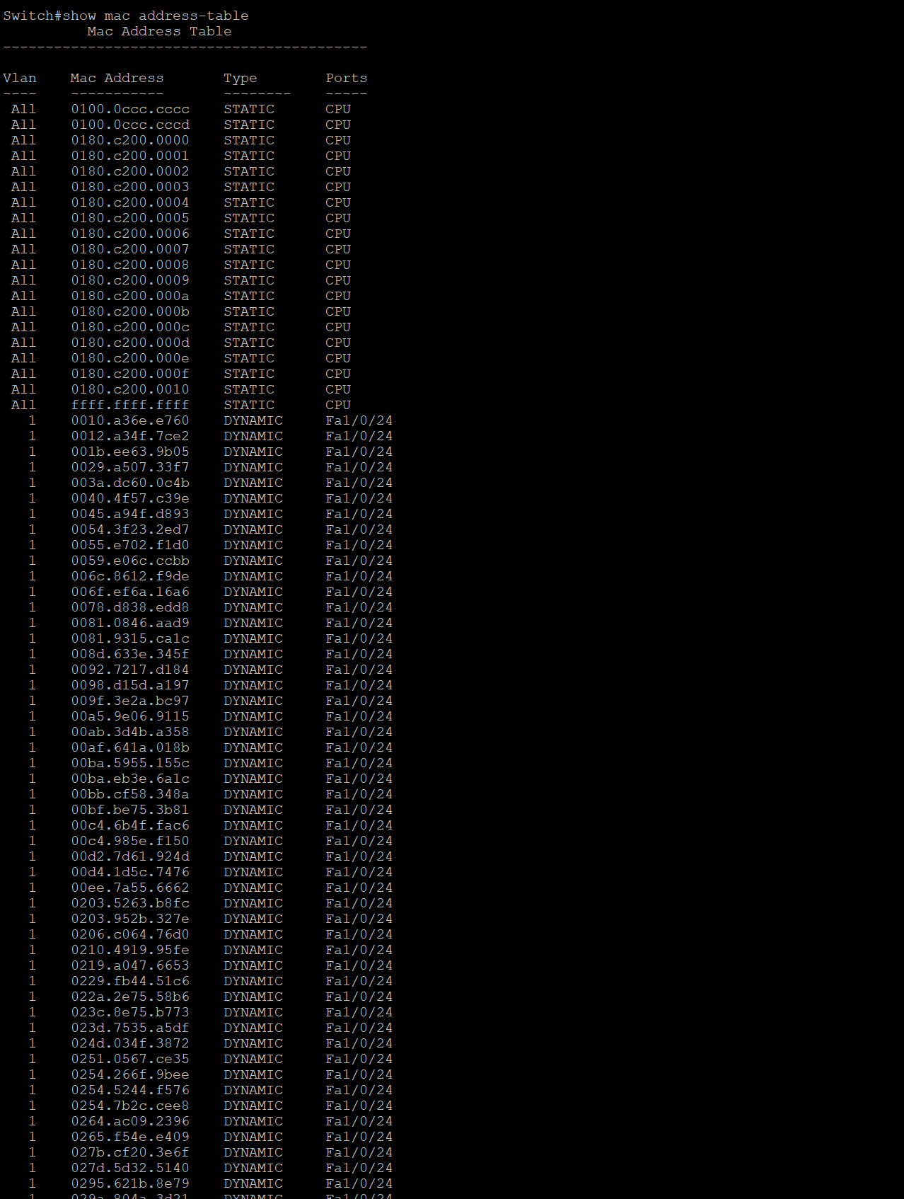
The clearest and easiest way to see if you attack worked is directly checking the CAM table of the switch that you attacked. The MAC address on normal to see on the CAM table.


But these extra MAC addresses all from the same address are from the MAC flooding attack. If the CAM table is full of these addresses, the attack was successful.

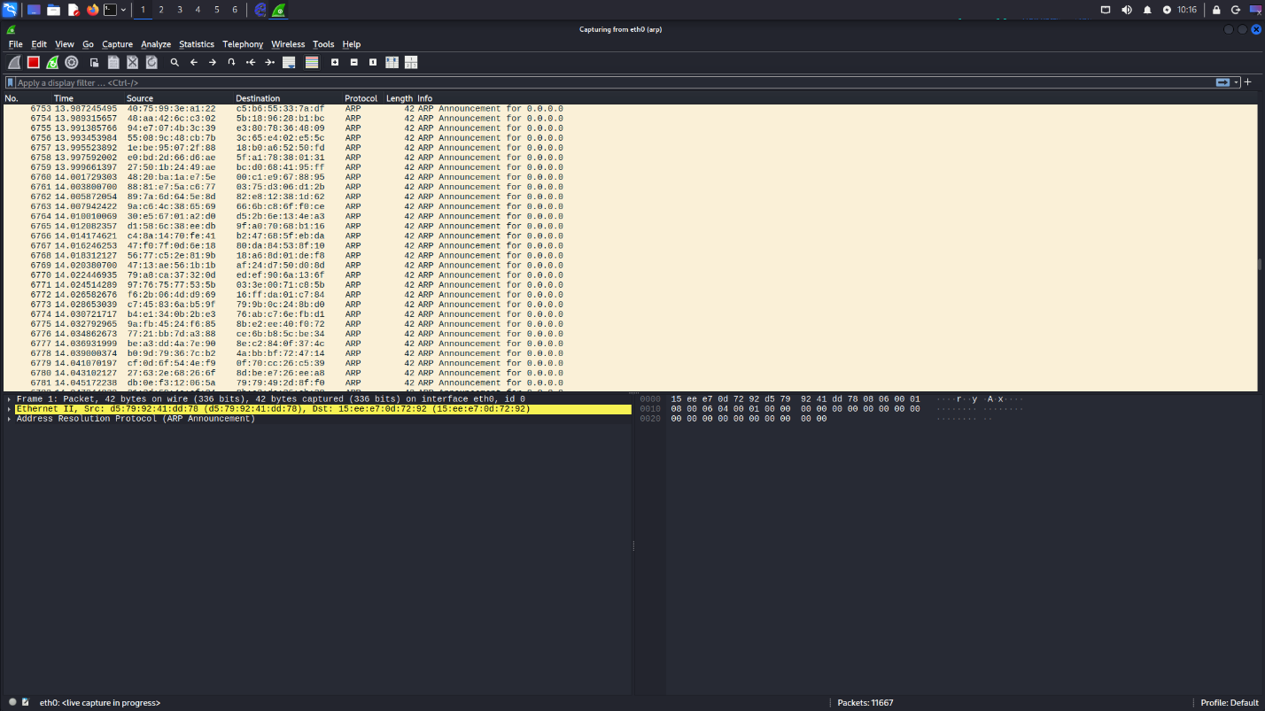
On Wireshark, you can also verify if your attack was successful. If it worked, you would see hundreds of ARP packets being sent over the network. This will fill up the switch’s CAM table, forcing it to broadcast packets through all interfaces except the one it was received from. Your attack was successful!

ARP Poisoning

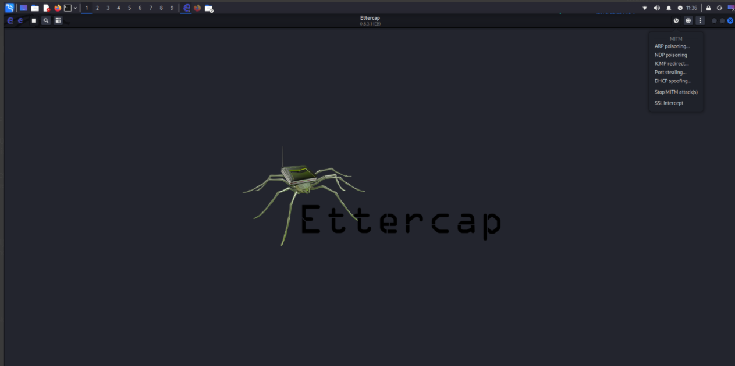
This time, instead of clicking the recording icon in the main menu, click the globe icon, then select ARP poisoning from the dropdown menu. Next, select manage plugins.

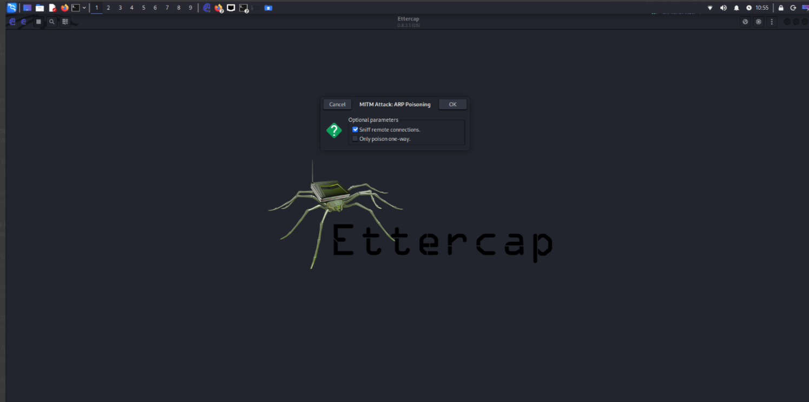
When the “MITM Attack: ARP Poisoning” menu pops up, select “OK”. Using this configuration, it will automatically sniff out hosts on the network and poison their ARP. You can also manually target specific hosts as well.

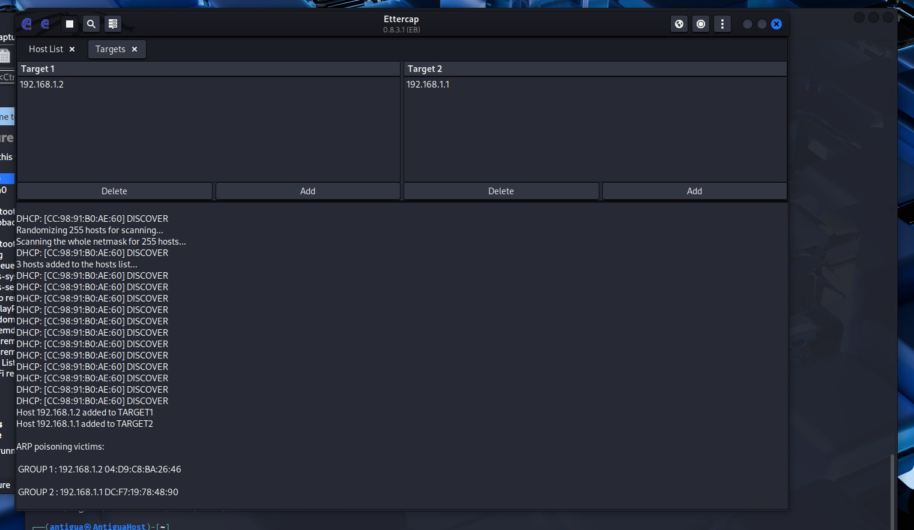

After starting the attack, this window should pop up. You will know that the ARP poisoning is happening when you see the ARP poisoning victims listed at the bottom left hand side of the screen.

To know if your ARP poisoning was successful, go back to the manage plugin menu and select “chk_poison”. Then click the check mark button to perform the function. Alternatively you can check the attack on wireshark where you will see detection of duplicate IP addresses meaning that your ARP poisoning was successful. 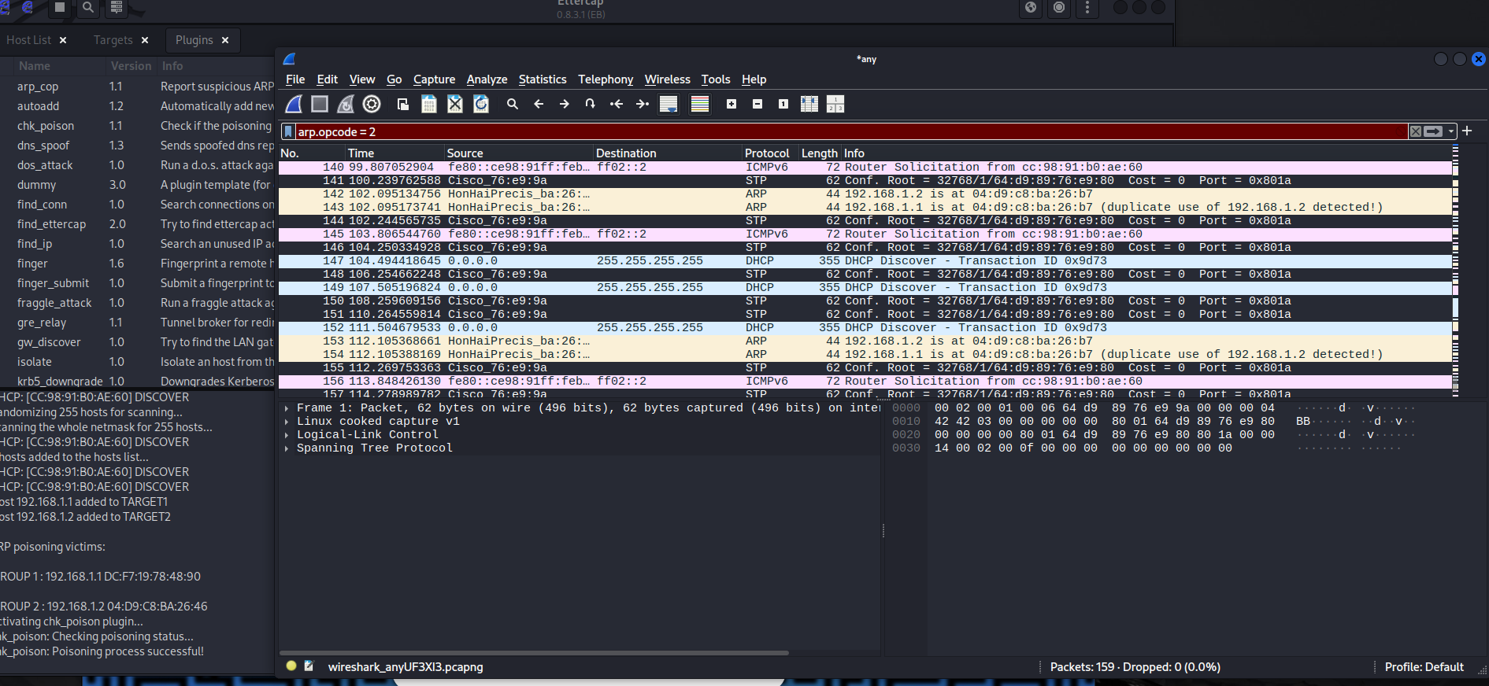
Either of these checks will signal that your ARP poisoning attack was successful!

Mitigations

Port Security
Switch(config)#int range f1/0/port number range)
Switch(config-if-range)#switchport mode access
Switch(config-if-range)#switchport access vlan (vlan number)
Switch(config-if-range)#switchport violation protect
Switch(config-if-range)#switchport port-security maximum (number)
Switch(config-if-range)#exit
This configuration first puts the interface onto the access mode and only allows traffic on a certain vlan to pass. As you saw in the attack, all the MAC addresses learned were on vlan 1, the default vlan. If we configure the switch onto a different vlan, these malicious addresses wouldn’t be accepted by the switch. Additionally, violation mode restrict will block the port and send a message if malicious activity is detected when more addresses are being learned that what is allowed. Finally, you can set the maximum number of MAC addresses the switch can learn through the maximum command.

Dynamic ARP Inspection

Switch(config)#ip dhcp snooping
Switch(config)#ip dhcp snooping vlan (vlan number)
Switch(config)#ip arp inspection vlan (vlan number)
Switch(config)#int range f1/0/(port number range)
Switch(config-if-range)#no ip arp inspection trust
Switch(config-if-range)#end

This is a simple command that you may use to help mitigate ARP poisoning. To turn on ARP inspection, DHCP snooping must be enabled generally and recommended to be enabled for the specific VLAN. Then turn on ARP inspection to make end user ports untrusted by default, which will mitigate the ARP poisoning the attack. You can also use the no ip arp inspection trust command on the interface to manually untrust a port.

Problems

Downloading Kali Linux
When we first attempted to download Kali Linux, we did not know how put it onto a drive. We did not realize that we would need rufus to help configure the USB itself to reimage the drive. Without rufus, we could not configure a file for the system to boot from. This essentially kept us stuck and unable to reimage the drive. But using rufus, we learned the proper settings to clear the drive completely and to make a file for the drive to be from and be reimaged.

Network Configurations
When we were configuring the network, we forgot a crucial set. This involves setting up the PC hosts. For traffic to be received through the network, we need to first turn off Window Defender Firewall. This was not crucial as it was not heavily affected by our attacks. But as we tested other attacks like attacking hosts themselves, we needed to turn off Windows Defender Firewall to let any traffic from the network reach the host. But all we needed to do was go into Control Panel and turn off Window Defender Firewall.

CAM Attack Problems
When we were attempting to flood the CAM table of the switch in our network. We did not configure the right interface to flood the CAM table from. This meant that all our packets were being flooded through a non-existent port, leaving us without a proper attack. We first noticed this when we used Wireshark and were unable to see any malicious ARP packets sent over the network. This was a quick fix. We changed the interface to eth0, solving the simple issue.

Conclusion

Based on our lab results, there are many different layer 2 attacks that network devices and networks themselves can be penetrated with. The attacks in this lab allow users to access and intercept data designated for different users and act as other users to manipulate a network. But by following simple best practice principles, we can mitigate the attacks easily, Port security and Dynamic ARP inspection.

